 | CSE40467 / CSE60467: Data Science  Milestone 1  Prof. Diego Gomez-Zara  TAs: Mariana Fernandez-Espinosa, Khiem Le

Team Number | Group 3
Members | Drew DiGuglielmo, Charlie Devine, Michael Sorenson, Dan Yoo
Date | February 10, 2026

Instructions:
- Maximum length: 10 pages, excluding members’ contributions and references.
- Put your responses inside the boxes.
- You can add figures in the boxes.
- Do not alter the font size (11-point), line spacing (1-line), or font typography (Times New Roman).
- References should be added by the end of the document. Use the format that you prefer (e.g., APA, IEEE, ACM, etc.)
- Please do not forget to cite when you make claims or references.

1. Introduction
  - What is your motivation to solve this problem?
The FIFA World Cup is a rare, high-stakes tournament where small differences decide outcomes and uncertainty is unavoidable. World Cup matches are relatively scarce, and they span very different eras and tournament stages, so the task naturally tests generalization and calibration under data constraints. Because each tournament includes only 64 matches, even simple performance claims can be unstable, which makes calibration and careful evaluation a central goal of this project (FIFA). Our goal is to build a reproducible pipeline that predicts match outcomes using only information available before kickoff, so the task reflects a realistic forecasting setting rather than hindsight. We frame prediction as four complementary lenses on team strength: (1) Memory (long-run World Cup pedigree), (2) Momentum (recent form and rest), (3) Skill rating (Elo-style latent strength), and (4) Goals-as-physics (a generative score model). Beyond accuracy, we emphasize well-calibrated probabilities and compare how uncertainty behaves in group versus knockout matches.

  - Why do we need an automated solution to predict/estimate these data? Please explain.
An automated approach helps because match outcomes are noisy and human intuition is inconsistent across games and eras. A reproducible pipeline lets us compare feature sets and modeling choices under the same evaluation protocol, and it lets us measure whether predicted probabilities match real frequencies, not just whether a winner was guessed correctly.
- Consistency and reproducibility. The same inputs produce the same outputs, so comparisons across models are meaningful.
- Scalability. We can run ablations, cross tournament validation, and repeated tournament simulations systematically.
- Uncertainty quantification. Instead of a single winner, the system outputs probabilities and we can evaluate whether they are trustworthy using calibration.

  - What kind of project are you presenting? Classification or Regression? Please justify with details.
This is primarily a multi-class classification project. For each match, the target label is the match outcome from one team’s perspective. In the group stage, the classes are Win / Draw / Loss. For knockout matches, we define the label by which team advances (including extra time and penalties), so there is no draw under this label.

As a secondary extension, we will also consider a scoreline distribution approach that models goals using a Poisson model and then derives win, draw, loss probabilities from the implied score distribution (Maher; Dixon and Coles). For all matches, we encode the label from a consistent reference perspective, treating the listed home team in the match table as Team A (Fjelstul).

2. Data description
2.1. What are the data objects, features, and labels of your dataset?
Data objects, unit of analysis
Our primary unit of analysis is the World Cup match. Each observation corresponds to a single match and includes the match date, tournament stage (group vs. knockout), and the two participating teams. The supervised learning target is the match outcome (Win/Draw/Loss for group-stage matches, and advancing team for knockout matches). To avoid look-ahead bias, we will train models using men’s World Cup matches up through 2018 and evaluate performance on the held-out 2022 tournament.

We explicitly control scope by mapping each dataset to a specific role in the pipeline. The Fjelstul World Cup Database, which covers men’s tournaments from 1930 to 2022, is our primary source for the supervised dataset and will be used to construct match labels, match metadata (date, stage, teams), and all engineered pre-kickoff features such as Elo ratings, recent form aggregates, pedigree measures, and rest day variables (Fjelstul). StatsBomb Open Data provides event and lineup data for the 2022 World Cup in JSON format, which we will use only for descriptive and explanatory analysis and not as predictive inputs for pre-kickoff forecasting (StatsBomb). The Gigasheet FIFA World Cup 2022 match stats sample provides pre aggregated match summaries for the 2022 tournament, which we will use only for exploratory plots and sanity checks, not as model features (Gigasheet).

Features
Our models will use only information that would be available before kickoff in order to prevent leakage and ensure a realistic forecasting setting. We will engineer a compact set of pre-match features that capture team strength, recent performance trends, and match context while ensuring that every feature is computed strictly from matches that occurred prior to the match being predicted.

To represent underlying team quality, we will include an Elo-style skill rating for each team along with the pre-match rating gap between opponents. These ratings will be updated sequentially over time using historical results so that each match’s features reflect only what would have been known at that moment (Hvattum and Arntzen). To capture short-term trends, we will add momentum features based on rolling summaries from prior matches only, such as rolling points per match and rolling goal difference over a fixed window. We will also include rest-related measures, specifically the number of days since each team’s previous match, to capture recovery time and schedule congestion effects.

In addition, we will incorporate longer-run “memory” or pedigree features derived from World Cup history prior to the match, including measures of experience and tournament pedigree such as total World Cup appearances, matches played, prior best finish, historical goals for and against, and knockout-stage win rate. Finally, we will include context variables to describe the match setting, such as whether the match is in the group stage or knockout stage, and, if necessary, year indicators to control for era effects when comparing matches across different tournament formats and scoring environments.

Labels
Our label definition depends on the tournament stage, reflecting how World Cup matches are decided. For group-stage matches, outcomes naturally include three possibilities, so we label each match from one team’s perspective as Win, Draw, or Loss based on the result at the end of regulation time. For knockout-stage matches, the tournament structure requires an advancing team, so we define the label as Win or Loss according to which team advances, counting outcomes decided in extra time or by penalties as wins for the advancing team and losses for the eliminated team.
In the match-level modeling table, the core identifiers and metadata come from match date, stage indicators, and the two team identifiers in the matches table, plus tournament year joined from the tournaments table (Fjelstul). The engineered feature table will include roughly 12 to 20 pre-kickoff inputs, grouped into skill rating, form, rest, pedigree, and stage context, while the label is Win Draw Loss for group matches or advancement for knockout matches.

2.2. Is it big data? How many data objects/features/labels do you have?
For the supervised learning task, our final modeling table is match-level. The Fjelstul World Cup Database match table contains 1,248 men’s World Cup matches from 1930 to 2022, and we train on tournaments through 2018 and hold out the 64 matches from 2022 for testing (Fjelstul; FIFA). The labeled table is modest in size, but the project still includes large scale data handling because the database spans 27 linked tables with over 1.58 million data points and StatsBomb provides high granularity event logs in nested JSON for descriptive analysis (Fjelstul; StatsBomb).

First, the Fjelstul World Cup Database has a high-volume, multi-table relational structure. The database describes itself as containing 27 datasets and over 1.58 million data points spanning tournaments, matches, teams, players, referees, appointments, and in-match events such as goals, bookings, substitutions, and penalty kicks (Fjelstul). As a result, our workflow must manage a multi-entity dataset with multiple keys and joins rather than a single flat file. The big data difficulty here comes from integrating many linked tables into a clean match-level modeling view while ensuring that every transformation is transparent, auditable, and reproducible.

Second, StatsBomb Open Data introduces high-granularity event data in nested JSON format (StatsBomb). The data are distributed as JSON exports organized into competitions, matches, events, lineups, and (for selected matches) StatsBomb 360 files. Even though we use this source only for descriptive analysis, it still brings classic big-data characteristics into the pipeline: large event logs per match, nested structures that require careful parsing, and non-trivial validation before meaningful summaries and visualizations can be produced.

Third, the project must reconcile multiple formats and heterogeneous schemas across sources. We work with match-level structured tables from the World Cup database, event-level JSON logs from StatsBomb, and pre-aggregated match summary statistics from the Gigasheet 2022 sample. Managing consistent identifiers across these representations, documenting differences in field coverage, and preventing leakage when moving between descriptive and predictive workflows are central challenges that align closely with big data concerns in practice.

=========

2.3. What are the types of features and labels of your dataset?
Feature types (model inputs: pre-kickoff only)
Our pre-kickoff models will use only information available before the match begins. Numeric features include Elo rating for each team and the Elo rating gap between opponents, rolling points per match and rolling goal difference over the prior k matches, and rest days computed as days since each team’s previous match. We will also include longer run pedigree and experience counts derived from prior World Cup history such as number of World Cup appearances, total World Cup matches played, and historical knockout stage win rate. Categorical features include tournament stage and round, for example group stage versus knockout stage, and optionally confederation and host status if these are available directly from our primary World Cup database tables and can be computed strictly from information known before kickoff. Date and time fields will be used only to enforce chronological ordering and to compute derived timing variables like rest days.

Data used for descriptive analysis only (not model inputs)
StatsBomb event and lineup data and the Gigasheet 2022 match stat summaries will be used only for exploratory analysis and post hoc interpretation. These sources describe what happened during or after matches, so we exclude them from pre-kickoff prediction features to prevent leakage. They may appear in figures that explain model errors or surprising outcomes, but they will not be used for training or evaluation of the forecasting models.

Label types
For classification, the label is categorical match outcome. In the group stage it is Win Draw Loss from a consistent perspective, for example Team A versus Team B. In the knockout stage it is Win Loss defined by which team advances including extra time and penalties. For the score model lens, the labels are the integer goals scored by each team in the match, which allows a generative model to produce a full scoreline distribution and derive Win Draw Loss probabilities by aggregating across score outcomes.

2.4. Are the labels balanced? How will you handle unbalanced datasets?
World Cup outcomes are not perfectly balanced. In the group stage, wins are typically more common than draws, and in the knockout stage our label is advancement, so the target becomes binary and draws are not a class. Because the label space differs by stage, we will analyze balance separately for group matches and knockout matches rather than reporting one combined distribution.

First, we will report class counts and empirical priors for the training period and for the 2022 test set, split by stage. We will include simple prior baselines for each stage so that learned model performance is compared against a transparent reference.

Second, we will evaluate with metrics that remain informative under imbalance. Alongside accuracy, we will report macro F1 or balanced accuracy for the group stage and probability focused metrics such as log loss and Brier score for both stages. We will also inspect calibration by stage because probability quality is central to our project goal.

Finally, if imbalance within the training period causes a model to over predict the majority outcome, we will use class weighted training for models that support it, such as logistic regression, and tune weights or regularization only using validation within the pre 2018 training window so the 2022 test remains a clean holdout.

2.5. Can you describe the data with statistics and plots?
We include descriptive statistics and plots that reinforce the four-lenses framing, summarizing outcome frequencies and goal distributions split by stage (W/D/L in groups; Win/Loss by advancement in knockouts) alongside descriptive distributions for goals, margins, and penalty-shootout variables. To connect pre-kickoff strength to outcomes, we visualize ΔElo and bin results by strength-gap, and we summarize rest days and rest differentials as scheduling context (FIFA; Hvattum and Arntzen). Part II adds reliability diagrams and other calibration visuals; any StatsBomb/Gigasheet-based figures are explicitly labeled as post-hoc/descriptive and excluded from model inputs.
We constructed a men’s World Cup match-level dataset from the Fjelstul World Cup Database v1.2.0 (Fjelstul) using the matches and tournaments tables, filtered to FIFA Men’s World Cup tournaments, joined tournament-year metadata, and performed basic type cleaning before exporting analysis-ready tables. We then split by tournament year to avoid look-ahead bias (1930–2018 train; 2022 test) and ran EDA by plotting (1) outcome class distribution, (2) distributions of key numeric variables (scores, margins, penalty-shootout variables), and (3) a correlation heatmap to inspect collinearity. These figures use post-match fields and are included only to summarize dataset characteristics and modeling considerations, not as candidate predictors for pre-kickoff forecasting.
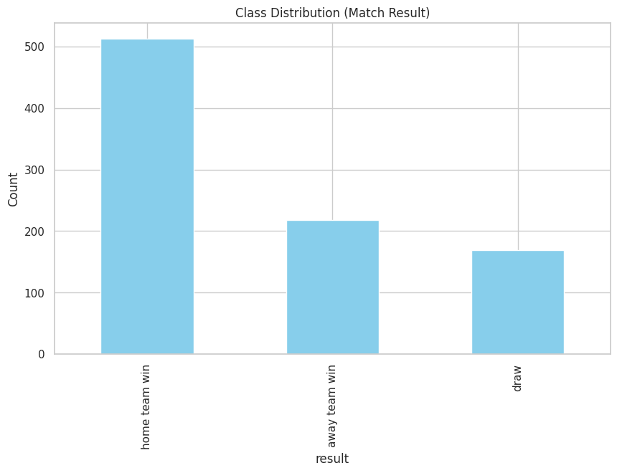
Figure 1. Class Distribution of Match Outcomes
This figure shows the distribution of outcomes under the dataset’s administrative home/away designation and indicates clear class imbalance. Matches labeled as the home team have the most wins (≈510), compared with away-team wins (≈220) and draws (≈170). We do not interpret this as a true home-field advantage because World Cup matches are typically played at neutral venues and the home label is an administrative designation in the match table (FIFA; Fjelstul). This motivates imbalance-robust metrics and stage-specific baselines so models are not rewarded for overpredicting the majority class.
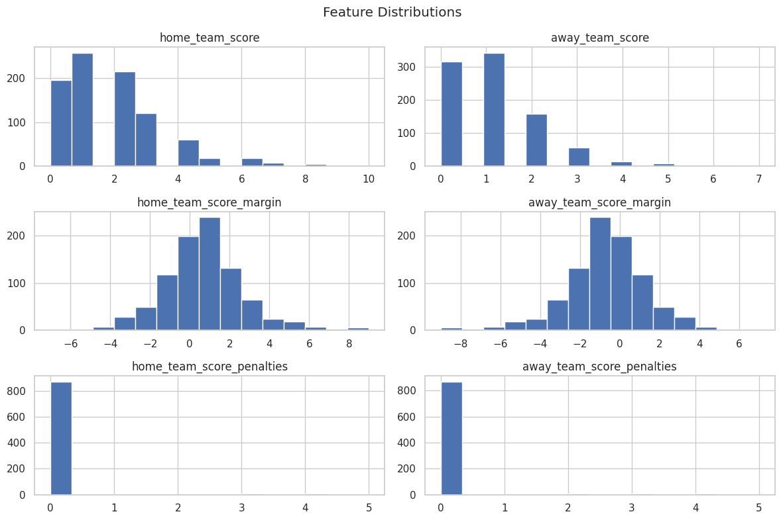
Figure 2. Distribution of Match Scores and Margins
This figure summarizes distributions of home and away goals, goal margins, and penalty-shootout outcomes. Goals are concentrated in the low-count regime, with the largest mass between 0 and 3 goals for both teams, and only a small tail extending to high-scoring outliers (up to about 10 for home-team goals and 7 for away-team goals in this dataset). Score margins are centered near 0, indicating that many matches are decided by small differentials rather than frequent blowouts, with most margins falling within a few goals of zero and a thinner tail reaching larger absolute values. Penalty-related variables are highly sparse: the modal value is 0, with only rare non-zero outcomes visible as a small tail up to about 5. Here, the ‘penalties’ fields refer to the match table’s recorded penalty-shootout counts/scores (when applicable), so we treat them strictly as post-match descriptors rather than predictive signals (Fjelstul). Because goals and penalties are post-match information, we treat these plots as descriptive context rather than pre-kickoff predictors; however, the low-scoring distributions also motivate Poisson-based score models when the target is goals (Maher; Dixon and Coles).
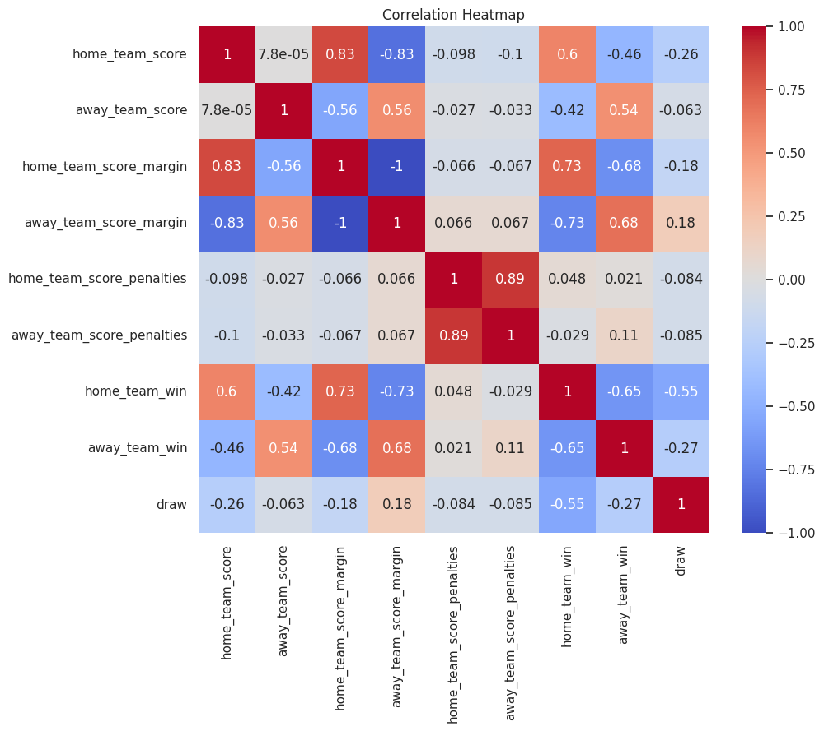
Figure 3. Correlation Heatmap of Key Variables
The correlation heatmap highlights several structural relationships among match variables and outcomes. Home and away score margins are perfectly negatively correlated (r = −1.00), confirming they are redundant encodings of the same information. Home goals are strongly positively correlated with home win (r ≈ 0.60) and with home margin (r ≈ 0.83), while away goals are positively correlated with away win (r ≈ 0.54) and negatively correlated with home win (r ≈ −0.42). Penalty indicators are strongly correlated with each other (r ≈ 0.89), reflecting that shootout variables co-occur when a match goes to penalties. These relationships are largely mechanical rather than a predictive discovery because scores and margins determine outcomes. Since score-derived variables are post-match information, we treat these correlations as descriptive only and exclude them from any pre-kickoff predictor set; later modeling focuses on pre-kickoff engineered features such as Elo gaps, rest days, form, pedigree, and stage context, while monitoring collinearity among those inputs.

Code and dataset links are provided in the submission ZIP but here is the GitHub Repo link:
https://github.com/drdiguglielmo-personal/datascienceproject.

2.6. Are there any data quality issues in your dataset?
We flag the main threats to validity up front so the evaluation reflects true pre-kickoff forecasting rather than hindsight. The primary risk is leakage because many match statistics such as possession, shots, and event sequences are only observed after the match. Our rule is that any variable created from in-match or post-match information is excluded from model inputs, so StatsBomb and Gigasheet are used only for descriptive analysis and post hoc explanation, not for training, tuning, or evaluating the pre-kickoff forecasting models. Any variable derived from goals, margins, cards, possession, shots, or event logs is excluded from the predictor set and is used only for descriptive figures.

Another limitation is the small size of the 2022 test set. The 2022 World Cup contains 64 matches, so test estimates can be noisy and sensitive to a small number of results. We will use time based splits by tournament year, training on tournaments up through 2018 and holding out 2022 for a final test, and we will tune any hyperparameters only within the training era using leave one tournament out cross validation to avoid look-ahead bias.

We will also consider cross era comparability, since the World Cup has changed over time in tournament format, number of teams, and style of play. To assess whether a model trained on older tournaments generalizes to newer ones, we will report performance by era and by stage when relevant, and examine whether both accuracy and calibration shift across periods.

Because we integrate multiple data sources, we will take care to ensure identifier consistency across datasets. Team names and identifiers can differ between the World Cup database, StatsBomb, and Gigasheet, so we will build a deterministic mapping table to standardize identifiers and validate joins using targeted spot checks to prevent mismatches from affecting analysis. This mapping is used only to align identifiers for descriptive joins and does not introduce any post-match variables into the modeling table.

Finally, we will document coverage differences in auxiliary data sources. StatsBomb event and 360 coverage may not be uniform across matches, and gaps in availability can limit interpretability analyses. Since these sources are descriptive only, missingness in them will not affect the core supervised dataset used for modeling, but we will clearly report what is available and where coverage limitations may affect downstream conclusions.

3. Potential Solutions and Evaluation Methods
3.1. Describe related work with this data source
This project builds on prior work in two areas. The first area is curated World Cup match databases and open event data that make longitudinal, match-level analysis possible at scale, including the Fjelstul World Cup Database and StatsBomb Open Data (Fjelstul; StatsBomb). The second area is probabilistic forecasting methods for soccer outcomes, including classical goal count models that induce win draw loss probabilities and rating based approaches that summarize team strength into a compact signal that can be evaluated for calibration and generalization across tournaments (Maher; Dixon and Coles; Hvattum and Arntzen).

For descriptive context and error analysis in the 2022 tournament, we will use StatsBomb Open Data, which is distributed through the open data repository as JSON exports organized by competitions, matches, events, and lineups (StatsBomb). This structure lets us link match identifiers to event and lineup context for post hoc interpretation, while keeping all predictive modeling restricted to pre-kickoff features derived from historical results (StatsBomb).

For the supervised modeling dataset, we will use the Fjelstul World Cup Database, which covers men’s World Cup tournaments from 1930 to 2022 and is organized as a multi table database (Fjelstul). The database documentation describes 27 datasets with over 1.58 million data points, which supports reproducible feature engineering at match-level and clean joins across teams, tournaments, and match metadata (Fjelstul).

For modeling methods, we will use classic score based approaches that treat goals as count outcomes and derive win draw loss probabilities from the implied score distribution, including Poisson based models such as those described by Maher and by Dixon and Coles (Maher; Dixon and Coles). In addition, we will use Elo style rating methods as a compact representation of team strength and a strong baseline for match outcome prediction, following prior work such as Hvattum and Arntzen (Hvattum and Arntzen).
3.2. Enumerate potential ways to solve this problem (e.g., classifier models, regression models, etc.)
We will compare several approaches that rely only on pre-kickoff information, organized around the same four lenses used throughout the project. We will implement them in a consistent build order so that each step isolates what new information is being added. For group stage matches, the prediction task is Win, Draw, Loss. For knockout matches, we use the advancing team label, so the task becomes Win, Loss.

Baseline priors. As a minimal reference, we will use stage conditional priors from the training data, predicting outcome probabilities using only historical class frequencies by stage.

Skill rating model. We will compute Elo ratings sequentially from historical World Cup matches so that each match uses only earlier results. Using the Elo rating gap as the main strength signal, we will predict outcomes with a probabilistic classifier such as multinomial logistic regression for group stage matches and a binary logistic regression for knockout matches (Hvattum and Arntzen).

Momentum and rest augmentation. On top of the Elo baseline, we will add rolling form features computed only from prior matches, such as rolling points per match and rolling goal difference, along with rest day measures. We will run ablations comparing Elo only against Elo plus momentum and rest to quantify the incremental contribution of short term signals.

Pedigree model. We will fit an interpretable classifier that uses long run tournament experience and performance summaries such as appearances, matches played, prior best finish, and historical goals for and against. This provides a transparent comparison to the Elo based approach by emphasizing experience and historical performance rather than recent results.

Score distribution model. We will fit a Poisson based score model using historical match results and then derive Win, Draw, Loss probabilities from the implied scoreline distribution. If feasible within time, we will include the Dixon and Coles adjustment to better handle low scoring dependence effects (Maher; Dixon and Coles).

Non linear classifiers. As an additional comparison, we may test tree based models such as random forests or gradient boosted trees on the same pre-kickoff feature set to capture non linear interactions. We will treat probability calibration and interpretability as primary criteria when deciding what to emphasize in the final write up.
For each model, we will output predicted probabilities and compare them under the same train validation protocol and the same set of metrics so differences reflect modeling choices rather than evaluation differences.

3.3. Design a non-machine learning baseline (i.e., random guess). If your data is unbalanced, how would you address it? How would you create a baseline if your problem does not involve a binary classification problem?
We will use simple non machine learning baselines that respect the competition stage and rely only on training set frequencies. These baselines give a fair reference point for interpreting learned model performance and make it clear how much lift we get beyond chance level prediction. All baseline probabilities are computed only from the pre 2018 training tournaments and never from the 2022 test set.

Group stage baselines (three class). For Win, Draw, Loss prediction, we will include three baselines. The first is a random guess baseline that assigns probability one third to each outcome. The second is an imbalance aware prior baseline that assigns probabilities using the empirical Win, Draw, Loss frequencies from the training group stage matches. The third is a majority class baseline that always predicts the most common group stage outcome in the training data.

Knockout stage baselines (two classes). For the advancement based Win, Loss label in knockout matches, we will similarly include a random guess baseline that assigns probability one half to each class, an imbalance aware prior baseline based on empirical training set knockout frequencies, and a majority class baseline that always predicts the more frequent class in the training knockout matches.

Because the group stage task has three classes and the knockout task has two classes, we construct these baselines separately by stage so the probability space matches the label definition. We will evaluate all baselines using both hard classification metrics such as accuracy and macro F1 or balanced accuracy, and probabilistic metrics such as log loss and the Brier score, so we can assess both classification performance under imbalance and the quality of the predicted probabilities.

4. Members’ Contributions
You must describe what each member contributed to the report. We will adopt the CRediT Taxonomy to describe each team member’s individual contributions. The submitting team member is responsible for providing the contributions of all authors at submission. We expect that all team members will have reviewed, discussed, and agreed to their individual contributions ahead of this time.

Contributor Role | Role Definition | Team Members  (List your names here)
Conceptualization | Ideas; formulation or evolution of overarching research goals and aims. | All
Data Collection | Activities to search for, obtain, download datasets. | Dan Yoo
Data Curation | Management activities to annotate (produce metadata), scrub data and maintain research data (including software code, where it is necessary for interpreting the data itself) for initial use and later reuse. | Drew DiGuglielmo
Formal Analysis | Application of statistical, mathematical, computational, or other formal techniques to analyze or synthesize study data. | Drew DiGuglielmo
Investigation | Conducting a research and investigation process, specifically performing the experiments, or data/evidence collection. | Michael Sorenson
Methodology | Development or design of methodology; creation of models | Drew DiGuglielmo
Project Administration | Management and coordination responsibility for the research activity planning and execution. | Charlie Devine
Software | Programming, software development; designing computer programs; implementation of the computer code and supporting algorithms; testing of existing code components. | Charlie Devine and Michael Sorenson
Validation | Verification, whether as a part of the activity or separate, of the overall replication/reproducibility of results/experiments and other research outputs. | Michael Sorenson
Visualization | Preparation, creation and/or presentation of the published work, specifically visualization/data presentation. | Dan Yoo
Writing – Original Draft Preparation | Creation and/or presentation of the published work, specifically writing the initial draft (including substantive translation). | Dan Yoo
Writing – Review & Editing | Preparation, creation and/or presentation of the published work by those from the original research group, specifically critical review, commentary or revision – including pre- or post-publication stages. | Charlie Devine

Works Cited
Dixon, Mark J., and Stuart G. Coles. “Modelling association football scores and inefficiencies in the football betting market.” Journal of the Royal Statistical Society: Series C (Applied Statistics), vol. 46, no. 2, 1997, pp. 265-280. Oxford Academic, https://academic.oup.com/jrsssc/article-abstract/46/2/265/6990546?redirectedFrom=fulltext. Accessed 16 02 2026.
FIFA. “FIFA World Cup Qatar 2022 at a glance.” insideFIFA, https://inside.fifa.com/tournament-organisation/world-cup-2022-in-numbers/fifa-world-cup-qatar-2022-at-a-glance. Accessed 16 02 2026.
Fjelstul, Joshua C. “The Fjelstul World Cup Database.” GitHub, 2023, https://github.com/jfjelstul/worldcup. Accessed 16 02 2026.
Gigasheet. “FIFA World Cup 2022.” Gigasheet, https://www.gigasheet.com/sample-data/fifa-world-cup-2022. Accessed 16 02 2026.
Hvattum, Lars Magnus, and Halvor Arntzen. “Using ELO ratings for match result prediction in association football.” International Journal of Forecasting, vol. 26, no. 3, 2010, pp. 460-470. ScienceDirect, https://www.sciencedirect.com/science/article/abs/pii/S0169207009001708. Accessed 16 02 2026.
Maher, M. J. “Modelling association football scores.” Statistica Neerlandica, vol. 36, no. 3, 1982, pp. 109-118. EconPapers, https://econpapers.repec.org/RePEc:bla:stanee:v:36:y:1982:i:3:p:109-118. Accessed 16 02 2026.
StatsBomb. “StatsBomb Open Data.” GitHub, 2019, https://github.com/statsbomb/open-data. Accessed 16 02 2026.

